Supplementary material
Table S1. Monthly values of large-scale climate indices, El Niño-Southern Oscillation (ENSO) and Southern Annular Mode (SAM), during the 2021–2022 study period.
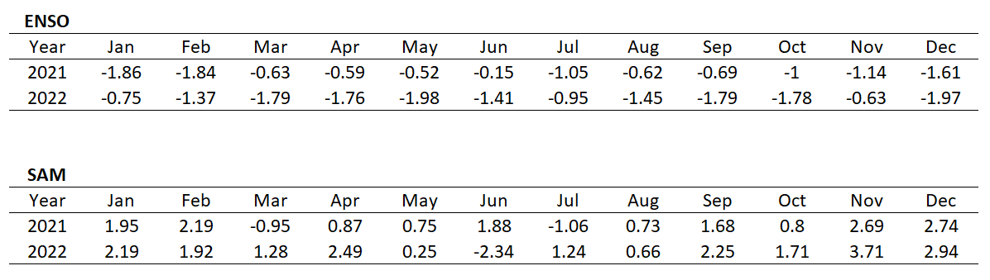
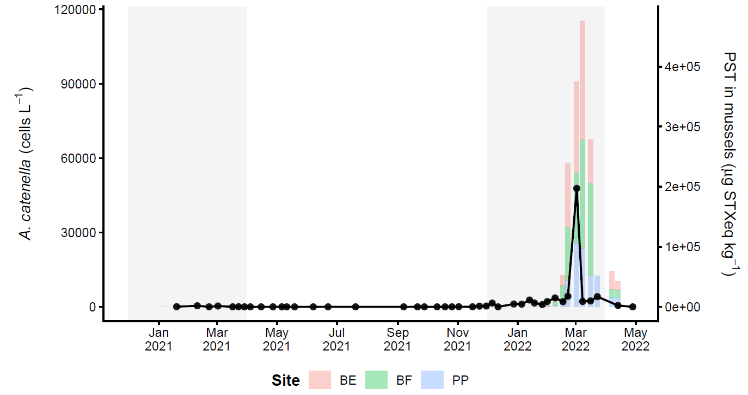
Figure S1. Temporal evolution of A. catenella abundance and associated PST from January 2021 to April 2022. Black lines and symbols indicate A. catenella cell abundance measured at station BE (light microscopy), while colored bars represent PST values measured in mussels at stations BE, BF, and PP (HPLC). The left y-axis corresponds to cell abundance (cells L⁻¹), and the right y-axis corresponds to PST values (µg STXeq kg⁻¹), scaled for visualization. Shaded areas highlight the austral summer periods (December–March). Note that PST levels during summer 2020–2021 were one order of magnitude lower than those recorded in summer 2021–2022 and are therefore barely visible at this scale. See Fig.1 for sampling locations.
Table S2. Optical characteristics of the water column during the annual time series at the three sampling sites. PAR: surface photosynthetically active radiation (μmol photons m⁻² s⁻¹). Kd: diffuse light attenuation coefficient (m⁻¹). Zeu: euphotic depth (m).
 |  |  |  | kd |  | Zeu |  | PAR (surface)
Area | Year | Month | Season | mean | SD | mean | SD | mean | SD
BE | 2021 | 1 | summer | 0.19 |  | 24 |  | 1123.3
BE | 2021 | 2 | summer | 0.22 | 0.08 | 23 | 7 | 1819.67 | 581.72
BE | 2021 | 3 | summer | 0.23 | 0.02 | 20 | 2 | 569.7 | 300.28
BE | 2021 | 4 | autumn | 0.26 | 0.04 | 18 | 3 | 1218.83 | 655.44
BE | 2021 | 5 | autumn | 0.23 | 0.03 | 20 | 3 | 583.24 | 686.13
BE | 2021 | 6 | autumn | 0.24 | 0.01 | 19 | 1 | 1440.27 | 518.4
BE | 2021 | 7 | winter | 0.22 |  | 21 |  | 271.7
BE | 2021 | 9 | winter | 0.34 | 0.07 | 14 | 3 | 903.63 | 267.16
BE | 2021 | 10 | spring | 0.37 | 0.01 | 13 | 0 | 1460.42 | 602.32
BE | 2021 | 11 | spring | 0.22 | 0.07 | 23 | 8 | 1293.45 | 1149.7
BE | 2021 | 12 | spring | 0.2 | 0.03 | 24 | 3 | 772.1 | 373.06
BE | 2022 | 1 | summer | 0.25 | 0.07 | 20 | 4 | 1856.59 | 981.65
BE | 2022 | 2 | summer | 0.22 | 0.03 | 21 | 3 | 1958.47 | 1047.3
BE | 2022 | 3 | summer | 0.28 | 0.07 | 17 | 4 | 818.3 | 323.08
BE | 2022 | 4 | autumn | 0.28 | 0.14 | 19 | 10 | 908.7 | 582.37
BE | 2022 | 5 | autumn | 0.21 |  | 22 |  | 184.59
BF | 2021 | 3 | summer | 0.34 | 0.1 | 14 | 5 | 709.4 | 571.88
BF | 2021 | 4 | autumn | 0.17 |  | 27 |  | 171.48
BF | 2021 | 5 | autumn | 0.26 |  | 17 |  | 237.5
BF | 2021 | 6 | autumn | 0.16 | 0.02 | 29 | 3 | 191.21 | 170.54
BF | 2021 | 7 | winter | 0.22 |  | 21 |  | 235.1
BF | 2021 | 9 | winter | 0.34 | 0.15 | 15 | 6 | 764.6 | 400.75
BF | 2021 | 10 | spring | 0.4 | 0.11 | 12 | 3 | 1338.78 | 450.96
BF | 2021 | 11 | spring | 0.24 | 0.02 | 20 | 2 | 1411.95 | 900.69
BF | 2021 | 12 | spring | 0.27 | 0.05 | 18 | 4 | 1902.67 | 1066.5
BF | 2022 | 1 | summer | 0.24 | 0.04 | 19 | 3 | 1978.93 | 1348
BF | 2022 | 2 | summer | 0.22 | 0.03 | 22 | 3 | 2441.1 | 1167.8
BF | 2022 | 3 | summer | 0.28 | 0.06 | 17 | 3 | 1495.28 | 938.33
BF | 2022 | 4 | autumn | 0.3 | 0.06 | 16 | 3 | 636.2 | 263.33
BF | 2022 | 5 | autumn | 0.2 | 0.01 | 23 | 1 | 469.9 | 174.23
PP | 2021 | 1 | summer | 0.3 |  | 15 |  | 1627.1
PP | 2021 | 2 | summer | 0.25 | 0.11 | 21 | 8 | 1120.2 | 463.97
PP | 2021 | 3 | summer | 0.19 | 0.07 | 27 | 12 | 962.6 | 1175.7
PP | 2021 | 4 | autumn | 0.26 |  | 18 |  | 2172
PP | 2021 | 5 | autumn | 0.17 |  | 27 |  | 253.8
PP | 2021 | 6 | autumn | 0.18 |  | 26 |  | 199.62
PP | 2021 | 7 | winter | 0.23 |  | 20 |  | 462.7
PP | 2021 | 9 | winter | 0.31 | 0.03 | 15 | 1 | 1138.84 | 786.49
PP | 2021 | 10 | spring | 0.28 | 0.04 | 16 | 2 | 1937.1 | 1238.7
PP | 2021 | 11 | spring | 0.21 | 0.04 | 23 | 5 | 634.55 | 310.81
PP | 2021 | 12 | spring | 0.27 | 0.02 | 17 | 2 | 1745.23 | 1043.3
PP | 2022 | 1 | summer | 0.24 | 0.03 | 20 | 3 | 2160.92 | 532.97
PP | 2022 | 2 | summer | 0.22 | 0.13 | 28 | 19 | 2517.77 | 1358.1
PP | 2022 | 3 | summer | 0.24 | 0.06 | 21 | 6 | 782.43 | 990.73
PP | 2022 | 4 | autumn | 0.18 | 0.06 | 27 | 8 | 458.6 | 11.03

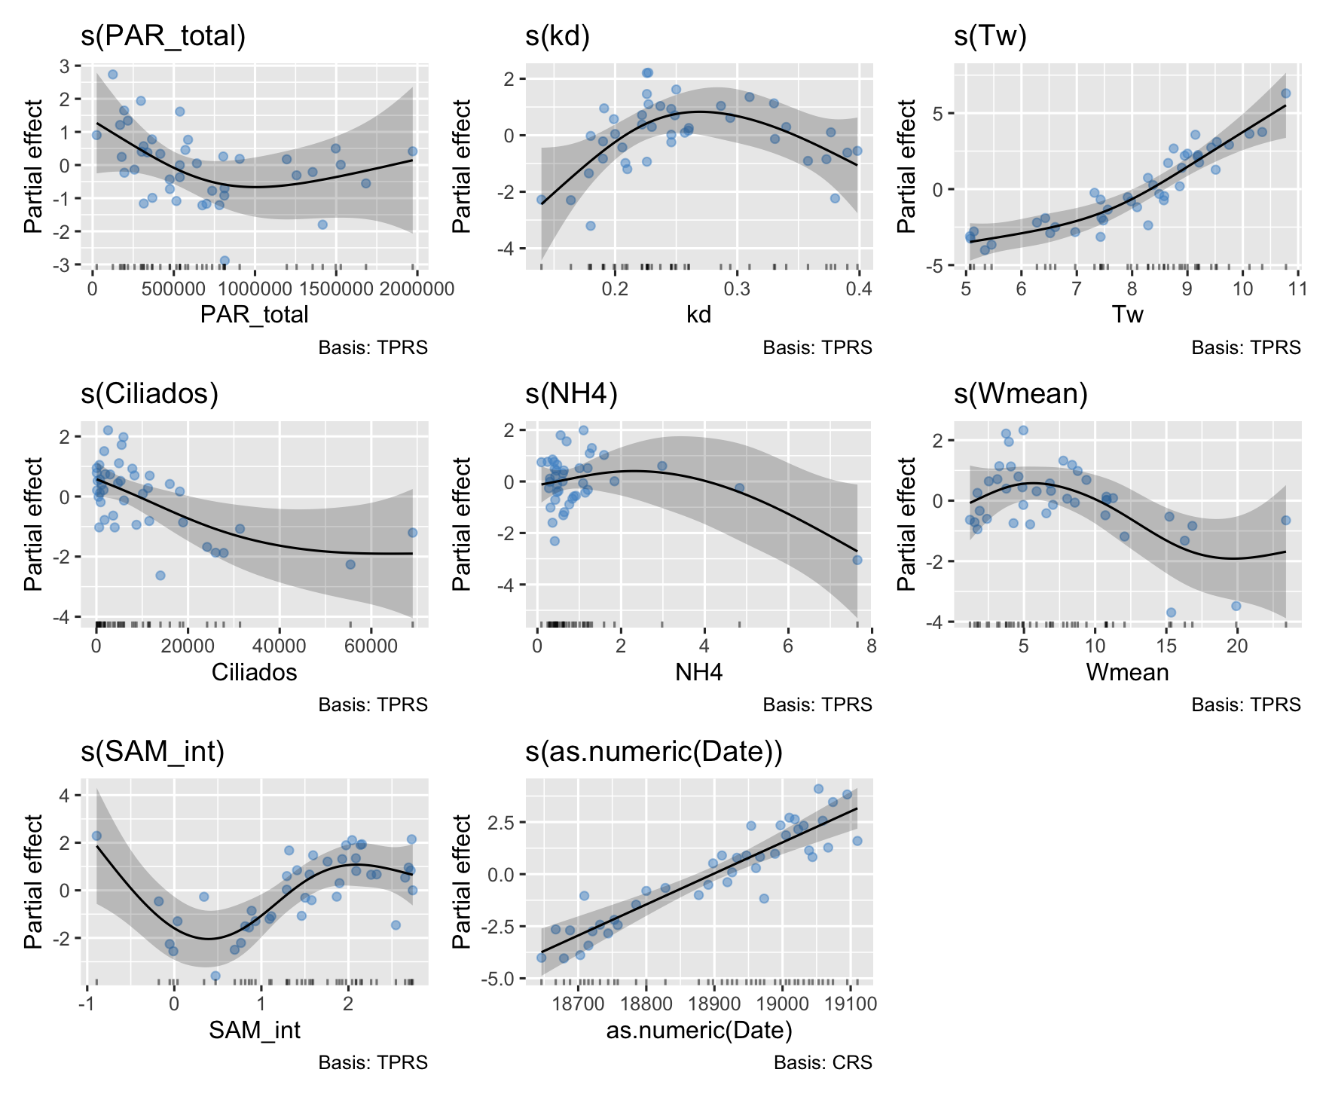
Figure S2. Partial effects of environmental and biological predictors on log-transformed Alexandrium catenella abundance at BE estimated using the final non-lagged generalized additive model (GAM). Smooth terms are shown for surface irradiance (PAR_total), diffuse light attenuation coefficient (Kd), water temperature (Tw), ciliate abundance, ammonium (NH₄⁺), mean wind speed (Wmean), Southern Annular Mode index (SAM_int), and sampling date. Solid black lines represent fitted smooth functions, grey bands indicate approximate 95% confidence intervals, blue points represent partial residuals, and rug plots show the distribution of observations along each predictor. Thin plate regression splines were used for environmental and biological predictors, and a cubic regression spline was used for sampling date.
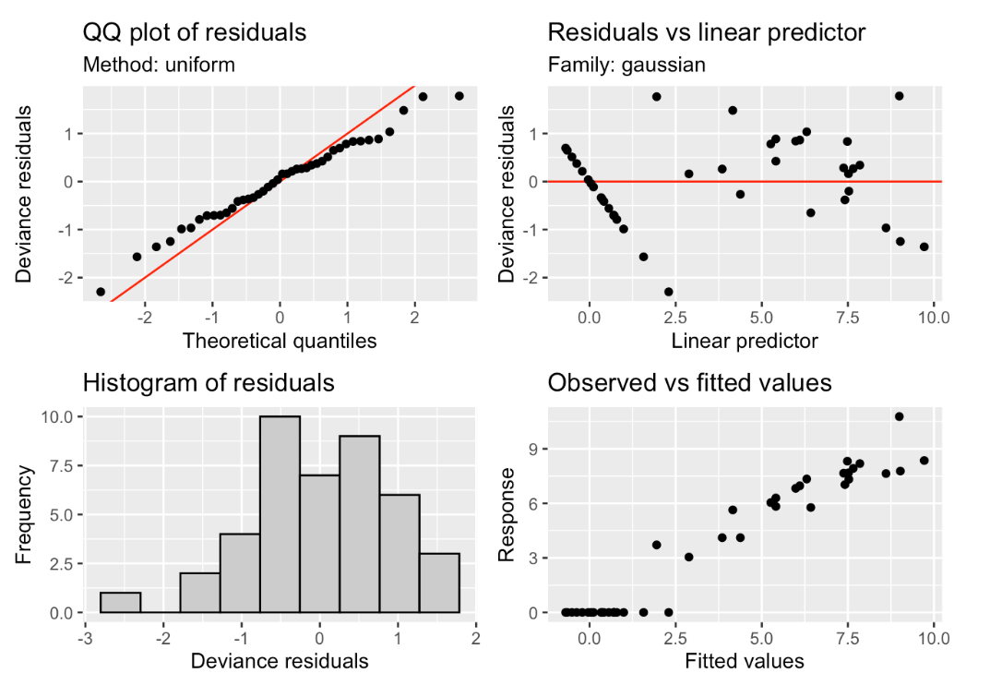
Figure S3. Diagnostic plots for the final non-lagged generalized additive model (GAM) fitted to log-transformed Alexandrium catenella abundance at BE. Panels show the quantile–quantile plot of deviance residuals, residuals versus linear predictor, histogram of deviance residuals, and observed versus fitted values. The diagnostics support the adequacy of the model for exploratory inference, while indicating moderate heteroscedasticity and a few influential observations associated with high-abundance bloom conditions.

